BADHWAR & O’NEILL 2010 (BO'10) GALACTIC COSMIC RAY (GCR) USER MANUAL

14 September 2010

(D:\GCR_BO10\BO'10 GCR USER MANUAL.DOC)

INTRODUCTION

The BO'10 GCR MODEL generates GCR energy spectrum (differential flux versus energy) from 1.0 to 1.0E6 MeV/n for one element (for z=1 to 94).

The code solves the Fokker–Planck equation for given PHI (the solar modulation parameter that describes the current state of the sun's ability to modulate cosmic rays) by propagating the element's (z) Local Interstellar Spectrum (LIS) to one (1) AU.

GENERATE GCR FLUX

Run GCRDR.EXE in DOS (enter the DOS command line by selecting run from the start menu on your desktop and then typing the word command).

INPUTS

The GCRDR .EXE code asks for the following inputs:

1) Drive used for the data file directory (default is D for D:\GCR_BO10\) but can use any drive you want (eg A:\GCR_BO10\). However, the directory name must be GCR_BO10.

2) The element charge (z)

3) Either the time (option a) or the level of solar modulation (PHI) (option b) for which the flux is needed.

For option a, entering the time interval, the GCR code derives the average value of PHI (solar modulation level) for the interval based on International Sunspot numbers (in the MONTHLY.TXT file).

A recent copy (2010 to August) of the MONTHLY.TXT file is in the D:\GCR_BO10 directory. However, that copy may shortly be out of date for your purposes.

If so, the MONTHLY.TXT file can be keep up to date by downloading the MONTHLY.TXT from:
ftp://ftp.ngdc.noaa.gov/STP/SOLAR_DATA/SUNSPOT_NUMBERS/INTERNATIONAL/monthly/MONTHLY
or
http://www.ngdc.noaa.gov/stp/
At this site, select
FTP Access
Directory SOLAR_DATA
Directory SUNSPOT_NUMBERS
Directory INTERNATIONAL
Directory MONTHLY
Then download the new MONTHLY.TXT file and toss the old one.

After the download, minor editing of the MONTHLY.TXT file is required. The GCR code automatically skips any line that does not begin with a number - so you do not have to delete any of the text or spaces that appear in the downloaded MONTHLY.TXT file.

However, the line with the last year must be edited such that it contains 12 entries (1 for each month) if it does not already. For example, if the file is downloaded just after July in 2010, the line for 2010 will only contain 7 sunspot numbers. In this case, you must enter -1.0 five times, so the last valid year line contains 12 months of sunspot numbers and the "minus" sign tells the GCR code that the last five months are not used.

The last 2 years in this case should look like:
2009 1.3 1.4 0.7 0.8 2.9 2.9 3.2 0.0 4.3 4.8 4.1 10.8
2010 13.2 18.8 15.4 7.9 8.8 13.5 16.1 -1. -1. -1. -1. -1.

For option b, entering a particular value of PHI, the code displays default values of PHI for solar minimum and solar maximum. This option does not use the MONTHLY.TXT sunspot file.
OUTPUTS

The output file flx.dat contains the modulated GCR differential energy spectrum for the selected element and PHI. The output file PHIFRISS.DAT contains PHI versus time as derived from the International Sun Spot file whenever option a is used.

UNITS
GCR energy spectrum (differential flux in #ions/m**2 sr s MeV/n
Versus energy in MeV/n)

SOURCES CODES

The following source codes used are:

GCRDR.FOR is an input driver

GCRMOD.FOR is the main routine that solves the Fokker–Planck equation

PHIFRISS.FOR derives phi from International Sun Spot number.

FATX.FOR is a utility used to find function values at a given value of x (ie f at x).

I compiled (Compac Visual Fortran) and linked these source codes (using GCR.BAT) to create the GCRDR.EXE executable. You do not need to be concerned with these source codes, but may use them as you desire.

DATA FILES NEEDED TO GENERATE GCR FLUX:

LISFSK.DAT - The LISFSK.DAT file contains the parameters (gamma, delta, and j0) for each element that describes the LIS for each element for z = 1 to 28.

SAMPLE GCR FLUX

You can generate the GCR flux (flx.dat) for each of the three data files in Figure 1 using the BO'10 GCR model. The data files are included in this delivery and the graph tells you the time and duration for each file. Try it!

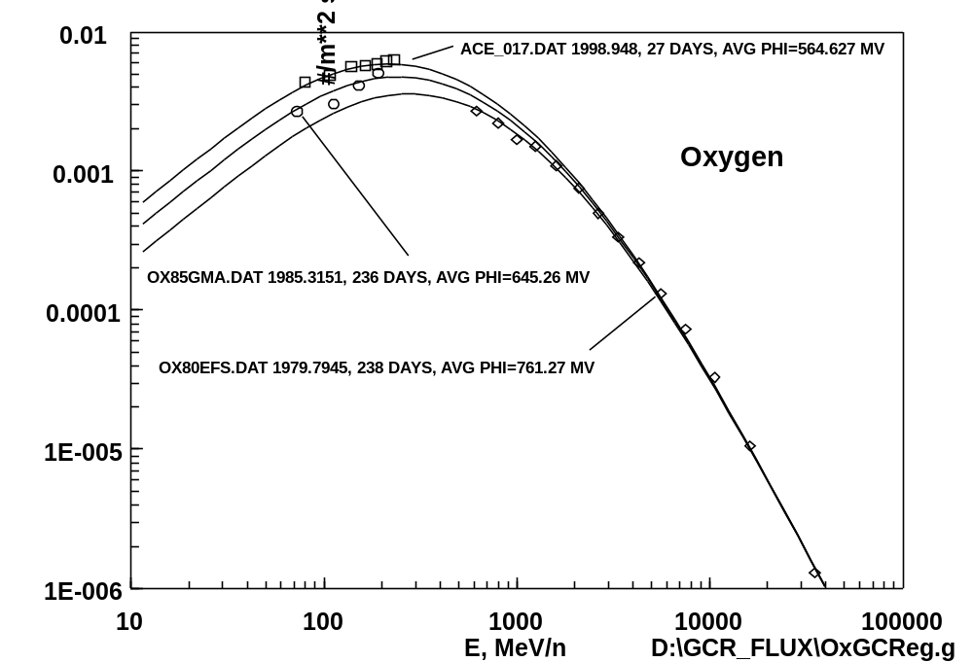

Figure 1 GCR flux versus energy for three different values of solar activity (PHI) near solar minimum showing agreement with GCR measurement files for both low and high energy

